**Indices & Index Laws; Exponential Functions; Differential Calculus – Notes**

**Find an equation of the tangent to the curve y = $\frac{x^{2}-x^{3}}{x^{4}}$ at the point where x = –1.**

y = $\frac{1}{x^{2}}$– $\frac{1}{x}$ → y’ = $–\frac{2}{x^{3}}$ + $\frac{1}{x^{2}}$ → x = –1 → y’ = 3 → y = 3x + c → (–1, 2) → c = 5

y = 3x + 5

**Find the coordinates of the point(s) on the curve y = $\frac{1}{x}$ + x with a gradient of 0.**

y’ = + 1 = 0 → x2 = 1 → x = 1 → (1, 2), (–1, –2)

**The curve y = ax3 + bx2 + 4x + 1 has a gradient of 2 at the point (–1, –4). Find a and b.**

y’ = 3ax2 + 2bx + 4 → 3a – 2b = –2 → –a + b – 4 + 1 = –4 → –a + b = –1

3a – 2b = –2, –3a + 3b = –3 → solve simultaneously → b = –5, a = –4

**Given that y = ax3 + bx2 + 2 has a tangent with equation y = –4x + 5 at the point where x = 1, find a and b.**

y’ = 3ax2 + 2bx → x = 1 → 3a + 2b = –4 → (1, 1) → a + b = –1

3a + 2b = –4, 3a + 3b = –3 → b = 1, a = –2

**A curve has equation y = $\frac{x^{3}}{3}$ + $\frac{x^{2}}{2}$– 4x + 1. The points A and B lie on this curve and the tangents to the curve at A and B are parallel to the line 2x – y = 5. Find the coordinates of the points A and B.**

y’ = x2+ x – 4 = 2 → y’ = (x+3)(x–2) → x = –3, 2 → (–3, 8.5), (2, $–\frac{7}{3}$)

**The tangent to the curve y = x3(x + 2) at the points where x = 1 and x = –1 met at the point Q. Find the coordinates of the point Q.**

y = x4 + 2x3 → y’ = 4x3 + 6x2 → x = 1 → y’ = 10 → y = 10x + c → (1, 3) → c = –7

x = –1 → y’ = 2 → y = 2x + c → (–1, –1) → c = 1

10x – 7 = 2x + 1 → 8x = 8 → x = 1 → (1, 3)

**The curve has equation y = (x – 2)(2x2 – 5x + 2). The points A and B lie on this curve. The tangents to the curve at A and B are parallel to the line 12x – y = 5. Find the coordinates of the points A and B.**

y = 2x3 – 5x2 + 2x – 4x2 + 10x – 4 = 2x3 – 9x2 + 12x – 4 → y’ = 6x2 – 18x + 12 = 12 =

6x(x–3) = 0 → x = 0, 3 → (0, –4), (3, 5)

**Use an appropriate derivative to evaluate $\lim_{h→0}{\frac{{\left(1+\sqrt{5+h}\right)}^{2}–(1+\sqrt{5})^{2}}{h}})$ giving your answer in exact form.**

(1 + )2 |x=5 → 2(1+) x |x=5 → |x=5 → $\frac{1}{\sqrt{5}}$ + 1 = $\frac{\sqrt{5}}{5}$ + 1

**Simplify each of the following, leaving answers with positive indices.**

**[a] $\frac{5^{n+1}–5^{n}}{8}$**

$\frac{5^{n}(5–1)}{8}$ = $\frac{(4)5^{n}}{8}$ = $\frac{5^{n}}{2}$

**[b] $\frac{5^{n+2}–5^{n+1}}{2(5^{n+1})}$**

$\frac{5^{n+1}(5–1)}{2(5^{n+1})}$ = $\frac{(4)5^{n+1}}{2(5^{n+1})}$ = 2

**[c] $\frac{7^{n–1}+7^{n}}{4 x 7^{n–1}}$**

$\frac{7^{n–1}(1+7)}{(4)7^{n–1}}$ = $\frac{(8)7^{n–1}}{(4)7^{n–1}}$ = 2

**[d] $\frac{3^{2n}+3^{n}}{3^{n+1}+3}$**

$\frac{3^{n}(3^{n}+1)}{3(3^{n}+1)}$ = $\frac{3^{n}}{3}$ = 3n–1

**[e] $\frac{2^{n+1}+8}{3(2^{n})+12}$**

$\frac{2(2^{n}+4)}{3(2^{n}+4)}$ = $\frac{2}{3}$

**Solve for t.**

**[a] 32t+1 = 81**

2t + 1 = 4 → t = $\frac{3}{2}$

**[b] 41-t = 32**

2(1–t) = 5 → 2 – 2t = 5 → t = $–\frac{3}{2}$

**[c] 52+t =**

2 + t = –3 → t = –5

**[d] 5t x 25t–1 = 0.04**

t + 2t – 2 = –2 → t = 0

**[e] $\frac{2^{2t+1}}{2^{1–t}}$ = 4**

2t + 1 – 1 + t = 3t = 2 → t = $\frac{2}{3}$

**Solve for x in (2x)2 + 2(2x) – 8 = 0.**

(2x + 4)(2x – 2)

2x = –4, 2 → x = 1

**Solve for x, 32x+1 + 8(3x) – 3 = 0.**

3(3x)2 + 8(3x) – 3

3y2 + 8y – 3 = 3y2 + 9y – y – 3 = 3y(y+3) – (y+3) = (y+3)(3y – 1)

3x = –3, $\frac{1}{3}$ → x = –1

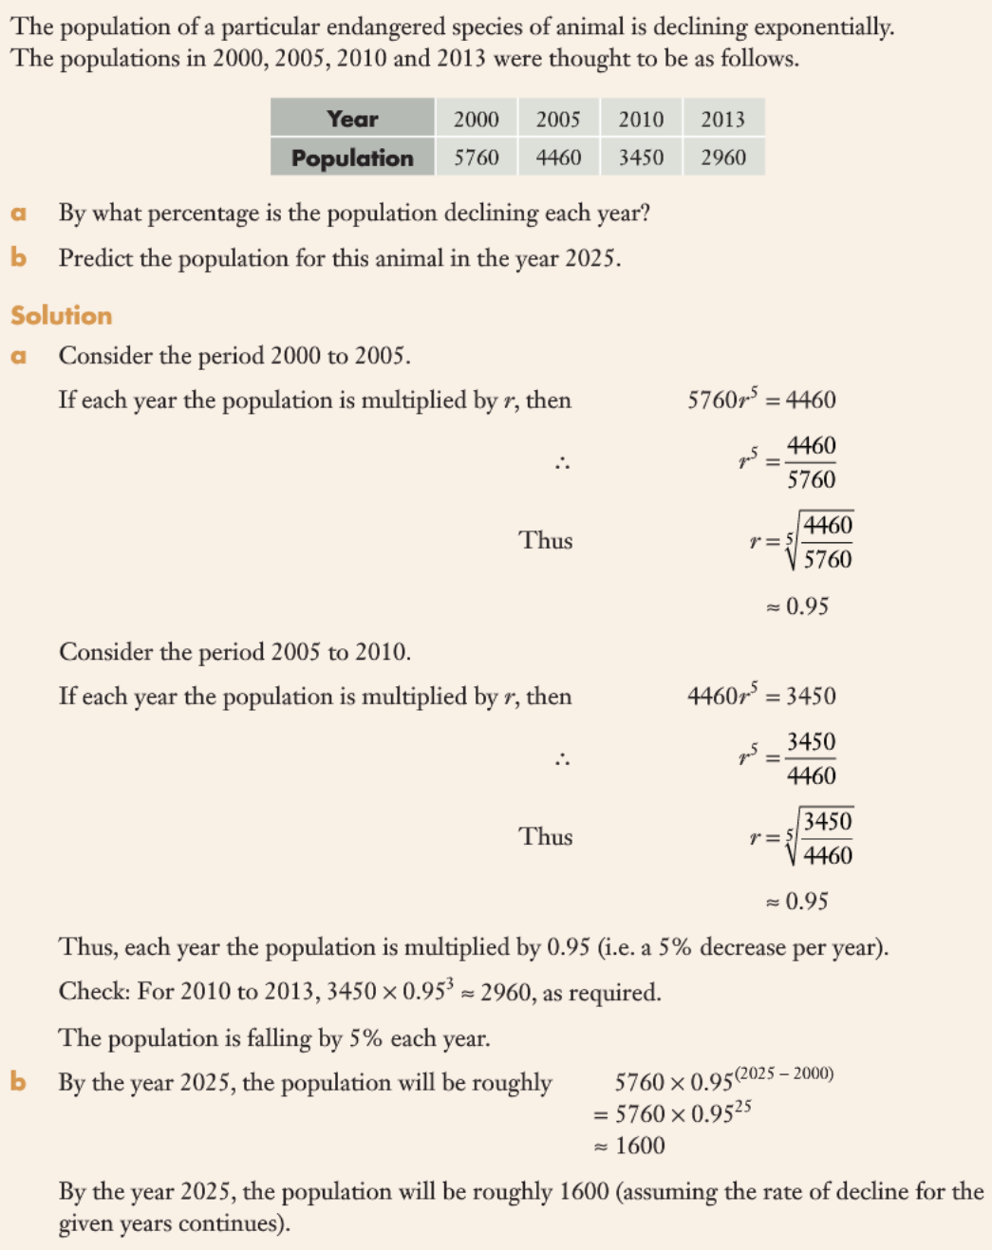

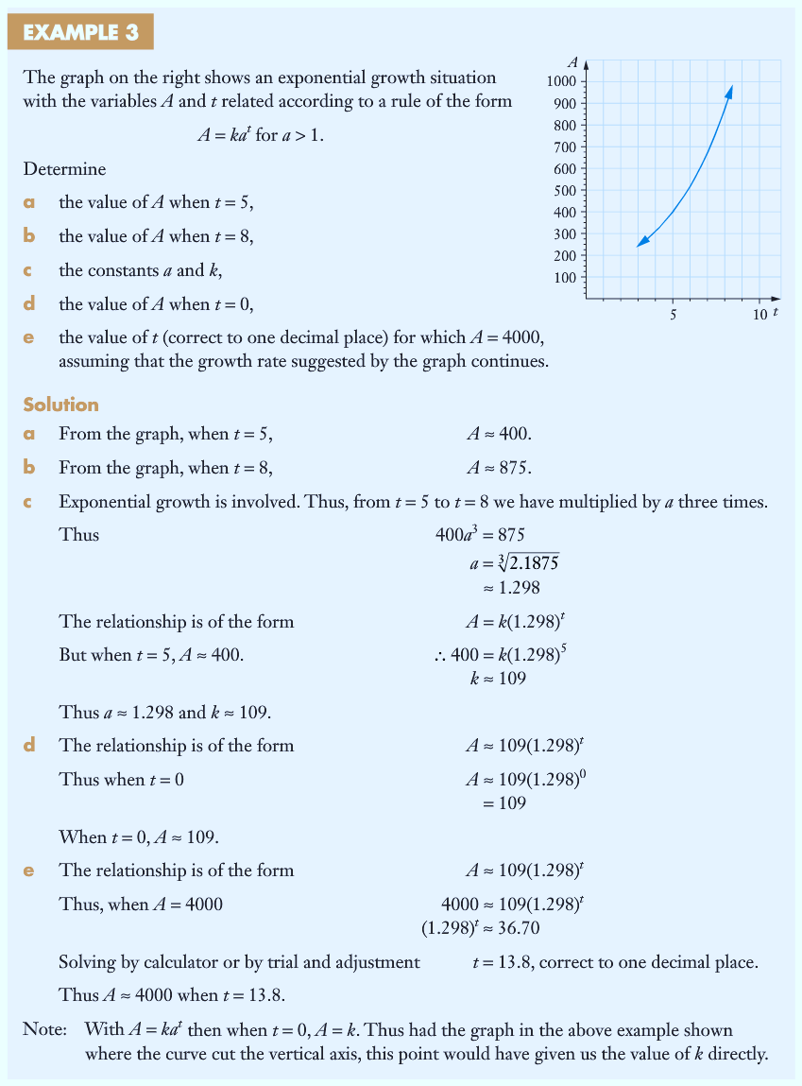

**Comment on the difference between your answers in part [b] and [d].**

Answer in [d] is the rate of change at that instant in time.

Answer in [b] refers to the average rate of change within an interval of time.